St. Colmcille’s Primary School
Calendar 2021 -2022

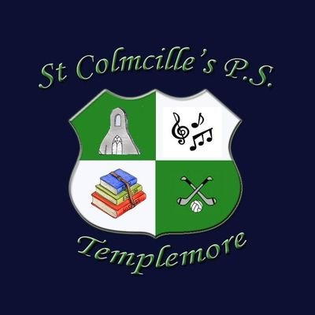

 | M | T | W | Th | F | M | T | W | Th | F | M | T | W | Th | F | M | T | W | Th | F | M | T | W | Th | F
Aug |  |  |  |  |  |  |  |  |  |  |  |  |  |  |  | 23 | 24 | 25 | 26 | 27 | 30 | 31
 |  |  |  |  |  |  |  |  |  |  |  |  |  |  |  |  |  |  |  |  |  |  | CP
Sept. |  |  | 1 | 2 | 3 | 6 | 7 | 8 | 9 | 10 | 13 | 14 | 15 | 16 | 17 | 20 | 21 | 22 | 23 | 24 | 27 | 28 | 29 | 30
Oct. |  |  |  |  | 1 | 4 | 5 | 6 | 7 | 8 | 11 | 12 | 13 | 14 | 15 | 18 | 19 | 20 | 21 | 22 | 25 | 26 | 27 | 28 | 29
Nov. | 1 | 2 | 3 | 4 | 5 | 8 | 9 | 10 | 11 | 12 | 15 | 16 | 17 | 18 | 19 | 22 | 23 | 24 | 25 | 26 | 29 | 30
Dec. |  |  | 1 | 2 | 3 | 6 | 7 | 8 | 9 | 10 | 13 | 14 | 15 | 16 | 17 | 20 | 21 | 22 | 23 | 24 | 27 | 28 | 29 | 30 | 31
Jan. | 3 | 4 | 5 | 6 | 7 | 10 | 11 | 12 | 13 | 14 | 17 | 18 | 19 | 20 | 21 | 24 | 25 | 26 | 27 | 28 | 31
Feb. |  | 1 | 2 | 3 | 4 | 7 | 8 | 9 | 10 | 11 | 14 | 15 | 16 | 17 | 18 | 21 | 22 | 23 | 24 | 25 | 28
March |  | 1 | 2 | 3 | 4 | 7 | 8 | 9 | 10 | 11 | 14 | 15 | 16 | 17 | 18 | 21 | 22 | 23 | 24 | 25 | 28 | 29 | 30 | 31
April |  |  |  |  | 1 | 4 | 5 | 6 | 7 | 8 | 11 | 12 | 13 | 14 | 15 | 18 | 19 | 20 | 21 | 22 | 25 | 26 | 27 | 28 | 29
May | 2 | 3 | 4 | 5 | 6 | 9 | 10 | 11 | 12 | 13 | 16 | 17 | 18 | 19 | 20 | 23 | 24 | 25 | 26 | 27 | 30 | 31
June |  |  | 1 | 2 | 3 | 6 | 7 | 8 | 9 | 10 | 13 | 14 | 15 | 16 | 17 | 20 | 21 | 22 | 23 | 24 | 27 | 28 | 29 | 30

School Holidays: School finishes at 12 pm
School reopens on Monday August 30th. Parent/Teacher meetings will be held on____________. These meetings will take place after school. Date forHoly Communion will be announced as soon as school is notified. In the event of unforeseen school closures, The B.o.M. may reduce the length of the Easter break by remaining open up to & including Wednesday 13th April 2022.

Please retain this calendar for your attention during the year.

